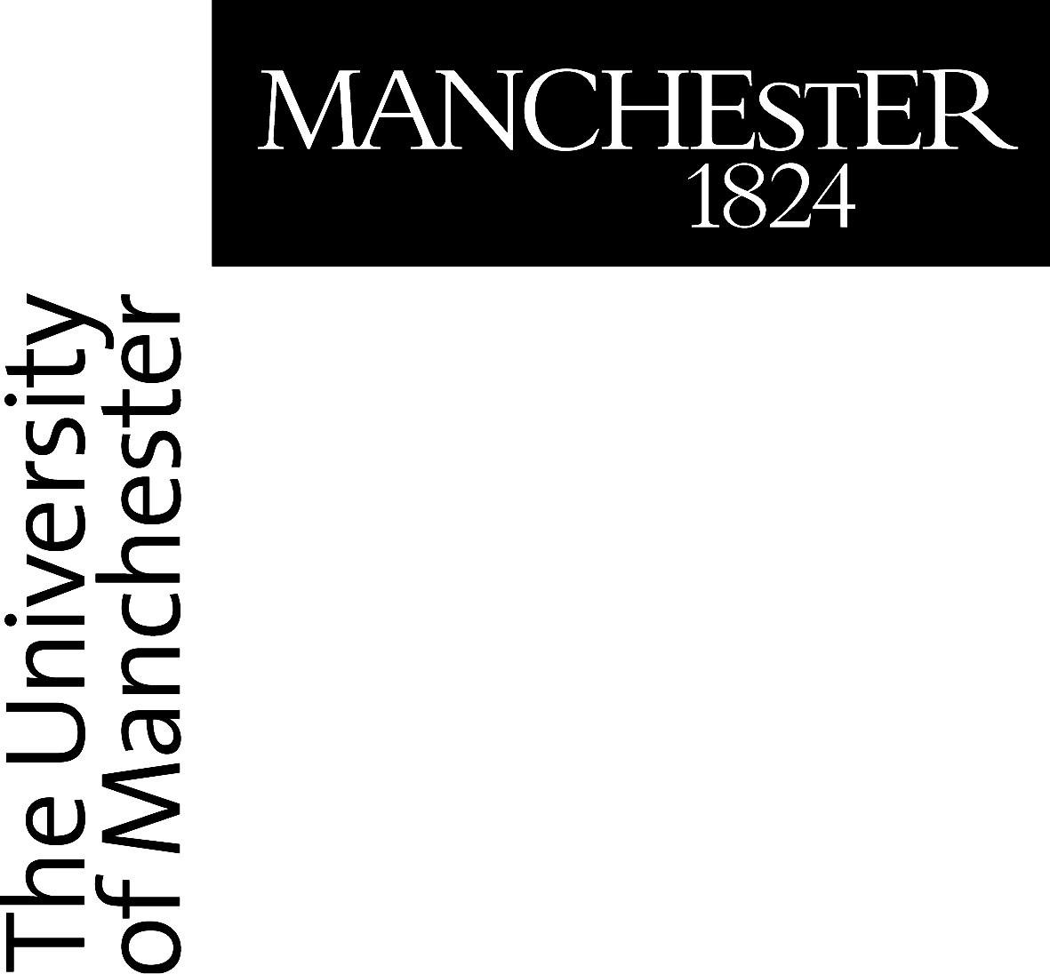
Museum Recommender System - Professionals Focus Group

CONSENT FORM

If you are happy to participate please complete and sign the consent form below

Please initial box

1. I confirm that I have read the attached information sheet
(Version 1.0, 14/02/2022) for the above study and have had the opportunity to consider the information and ask questions and had these answered satisfactorily.
2. I understand that my participation in the study is voluntary and that I am free to withdraw at any time without giving a reason and without detriment to myself. I understand that I am able to withdraw my data for up to 14 days after participation, but that after this point it will not be possible to remove my data from the project. I agree to take part on this basis
3. I understand that the study will be audio-visually recorded
4. I agree to the use of quotes
5. I agree to the use of anonymous quotes
6. I agree that any data collected may be passed on as
anonymous data to other researchers

Data Protection
The personal information we collect and use to conduct this research will be processed in accordance with data protection law as explained in the Participant Information Sheet and the Privacy Notice for Research Participants.

I agree to take part

_____________________ ______________ ______________________________
Name of Participant Date Signature

Lukas Noehrer
_____________________ ______________ ______________________________
Name of the person taking Date Signature
consent

